An evaluation of the
Memory Café at
St Cuthbert’s Church
North Wembley

The Memory Café enlivens my week. I can say goodbye to loneliness and depression.
Memory Café member

Eddy Knasel and Anna Rossetti for Learners First
Introduction
In September and October 2016 Learners First, a specialist qualitative research and evaluation consultancy, carried out an evaluation of St Cuthbert’s Memory Café on behalf of the Revd Steve Morris and the Church.
Two visits were made to the Church on September 8th & 15th 2016 to observe the Café in action. Face-to-face interviews were carried out with members and key informants. A questionnaire was devised after the first visit and given to members to complete during the second visit. (The questionnaire is included as an Appendix). Telephone interviews with Revd Morris and Hazel, an original member of the core team, took place in October.
The aim of this evaluation us to give a detailed portrayal of the Memory Café, to assess its impact, its benefits to members and to identify key factors contributing to its success.
The intention is that the findings will enable St Cuthbert’s to:
• continue to improve what it offers;
• secure future support for the Café;
• raise its profile within and beyond its local community;
• encourage and help others to provide similar services to their own communities.

Report of findings
The origins of the Memory Café at St Cuthbert’s
Consecrated in 1959, St Cuthbert’s Church in North Wembley is a light and airy building within a diverse, primarily Hindu, community. Attendance at Sunday worship is relatively low, but in September 2015 the parish began to run a weekly Memory Café in association with the Alzheimer’s Society. The initiative for the Café came from the Vicar, Revd Steve Morris, who was determined to serve his parish by offering something that would help those suffering from isolation, loneliness and memory loss.
At his previous parish Revd Morris had seen a close colleague and mentor suffer dementia. He was deeply affected by the experience and motivated to do something to support others with the condition. He also felt that St Cuthbert’s could do more to connect with its community and wanted to reach beyond the relatively small number of people coming for regular worship:
I wanted to reconnect with the community we served. My aim was to be a blessing to the parish as a whole.
Hazel, a member of the original core team that set up the café, has been active in the Church since 1982. She recalls when she first heard of the idea.
At the end of August 2015 Steve said that we should be thinking of doing something for people in the community with dementia and asked who was interested. My mother has Alzheimer’s and I wanted to understand it a bit better.
Steve had heard of memory cafés and thought the idea could fit with what he saw as his mission. He did not know how they worked in practice. Hazel and her colleague Lyn had concerns about how the new venture might work out:
We had a list of possible problems in our minds; we were worried about how we would cope, how we’d organise the sessions and what we’d do in them. Would it work and would people come?
Core team member
Steve approached the local branch of the Alzheimer’s Society to ask for help. They already had a part-time worker – Adrian – who was running a few regular memory café sessions in the area. The Society agreed that Adrian could work with Steve to help establish a new café at the Church. Hazel says that her worries vanished when she found out that they would be getting help from someone with experience of running sessions.
The memory café is held in the half of the church nearest the entrance. It is a comfortable space with blue carpet on the floor and 8-10 large round tables arranged in café style.

Marketing the Memory Café
Steve Morris ran a successful marketing consultancy before he became ordained, so perhaps it is no surprise he was able to attract people from the start. He featured the Café in a regular column he writes for the local Residents’ Association magazine. The Café was also advertised by the Church in a flyer and on a large poster. The main visual motif is a cup of tea.
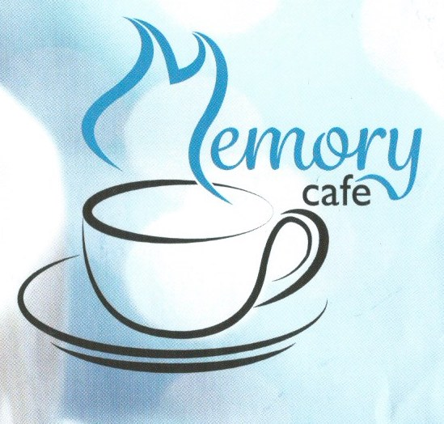
Over the years you get used to thinking ‘That’s a good idea’ and then hardly anyone comes. I was completely staggered at the number of people who turned up.
Core team member
More than twenty people were drawn to the first meeting of the Café in September 2015, the majority of them have continued to come every week. Adrian reports that from the first session the St Cuthbert’s Café has been the largest of the four he facilitates.
There is evidence that the marketing materials hit the right note by stressing the social ‘tea and biscuits’ aspect of the Café. A 73 year-old member who has been widowed for 15 years says:
Dementia wasn’t over emphasised, just company and games. I thought that would suit me so I came the first week and brought three friends with me. The people are lovely, just lovely.
Not having an exclusive emphasis on dementia seemed to us to influence the atmosphere of the Café. While only a few members may actually have a dementia diagnosis, many are keen to keep their minds and memory active. It’s easy to become isolated if you live alone and many members come to the Café simply because of the excellent company they find there. Even if an older person doesn’t have dementia, many worry about their memory; either because they already find some words or names harder to recall or because they fear for the future. And it is understood that isolation can itself lead to dementia. From the very beginning the team wanted the Memory Café to be open to everybody.
For years we’ve been aware that there’s a problem with loneliness on the estate. It’s quite a community round here and there are a lot of older people living alone. I was aware of it from the door-to-door collections I used to make.
Core team member
The numbers attending have continued to grow. Active marketing continues through flyers, the local press and word-of-mouth. Revd Morris describes the strategy:
We put flyers (1,500) through every door in the parish three-times a year. And I always carry a flyer around with me and hand it out when it seems right. I have a monthly column in the Residents Association Magazine. There’s an A Board permanently outside the church and a big poster on the notice board.
It is clear, though, that one of the most effective ways in which the Café is marketed is by word-of-mouth. Every member is a passionate advocate for the Café; many have brought friends along with them and nearly all we spoke to said they had encouraged other people they know to come.
One of the carers summed this up:
I think of it as the ‘ripple café’ – the ripple effect. You find out about it from the church or the local community.
A welcoming atmosphere
It’s very friendly, we’re all the same - no judgements are made here. Everyone has memory problems but to different extents. I think some come because they are lonely.
The warmth of the welcome to newcomers is a striking feature of the Café. When we arrived on our first research visit, several members came over to ask who we were, where we were from and if we wanted tea or coffee. Although people are chatting to each other, it doesn’t feel noisy, just a comfortable, friendly hubbub. Everyone is given a sticky label with their name on to wear.
Once we had sat down, more came over and introduced themselves, telling us how good the Café was and how much they enjoyed it.
Everybody is so accepting and there are very few places where people are accepting without conditions.
Café member
There were about 40 members on our first visit – the largest turnout so far. The members sat at round tables (5-6 per table), arranged in the half of the Church nearest the entrance. There were slightly more women than men. The majority were white but there were also a good number of Asian and Afro-Caribbean (BME) members. About half of the members are aged 75 or more.
We just want to make people feel welcome and as if they belong somewhere.
Core team member
Although the total group was a mix of dementia sufferers, carers and volunteers, everyone was described as a ‘member’ and it was not immediately obvious which category any individual fell into. One member who attends a different church commented to a core team member, ‘What I really like is that I’ve no idea who’s got dementia and who hasn’t.’
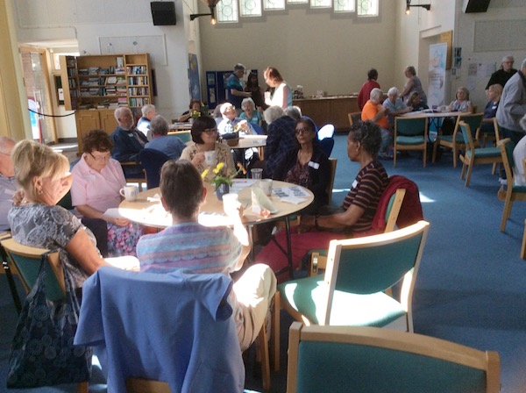
Our second research visit followed a week later. There were even more people present, perhaps attracted by the presence of the Mayor of Brent. This time, children from Happy Days Pre-School nursery, which is based at St Cuthbert’s Church Hall, were present for the beginning of the meeting.
Serving the whole community
Membership of the Memory Café reflects the make up of the community. Only a minority are active Christians, many are Hindus, Sikhs or Muslims, while some are agnostics or atheists. There is also diversity amongst those who identify as ‘Christian’, with Catholics as well as Anglicans attending.
This very much reflects Revd Morris’ own philosophy of seeing himself as ‘priest to the whole parish’:
I’m the priest for everyone in the parish, not just the Christians. My job is to express God’s love for people – with no strings attached.
The core team had experience of previous church initiatives for older people. They had run a monthly session called ‘Tea at 3’ but this was much more focused on the church with a certain amount of religious content as well as crafts and a quiz, although anyone could attend. Most of the people who came to Tea at 3 now come to the Memory Café so it was slowly dropped.
Many of the members value the multicultural and multi-faith aspect of the group, one response to the questionnaire item ‘What do you think is the best thing about the café?’ was, ‘Meeting people from other cultures and religious beliefs.’
Kawal, a Sikh who attends the Café as carer to her husband Hari, told us:
We appreciate the church extending the facility to other faith groups. We see that they are using the facility and that their intention is noble – to reach out and open up. It would be good to see more places of worship opening up and reaching to their communities, not just their own attenders.
The structure of the sessions
The two-hour sessions at St Cuthbert’s follow a pattern common to memory and dementia cafés supported by the Alzheimer’s Society. Sessions start with a guest speaker, followed by activities designed to help older people to exercise their mind and brain, and close with notices about future events.
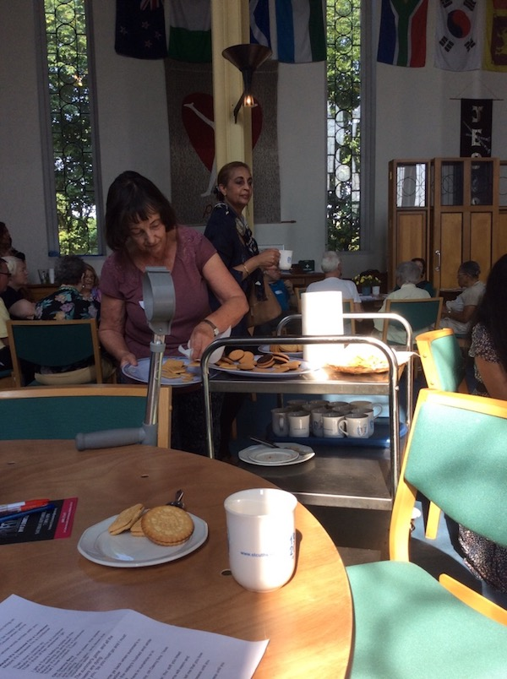
Tea, coffee and biscuits are available throughout the session, either at the serving counter or from a trolley that is taken around the tables.
Speakers
After welcoming members there is usually a guest speaker. On our first visit this was a talk about a system for monitoring people’s homes so that carers are alerted to emergencies. At our second visit a guest singer/guitarist sang songs typically familiar to an older audience of Londoners such as ‘Tulips from Amsterdam’, ‘When you’re smiling’ and ‘Maybe it’s because I’m a Londoner’. The guest of honour, the Mayor of Brent, then said a few words.
Activities – quizzes
The guest speaker is followed by a series of activities lead by Adrian, the facilitator. These can include:
• Written quizzes – on general knowledge, food and drink or maths questions.
• Visual quizzes – e.g. pictures of people from history, identifying animals.
• Customised crosswords, personalised, e.g. with names or home countries.
• ‘Spot the difference’ – comparing two closely similar pictures.
Adrian told us that although there are quizzes that can be downloaded from the internet, he writes them ones he uses himself, taking account of his knowledge of individual group members.
The overall aim of the activities is to slow down the advance of dementia through:
• Cognitive simulation – exercising the mind and brain, helping concentration and memory through recollection.
• Encouraging social interaction – if people are forgetful and remember something or help someone else, this enhances wellbeing and self-esteem.
• Enhancing emotionality – for example smiling and laughing, aids wellbeing.
• Reducing social isolation – being alone and isolated can itself contribute to the onset of dementia; this café is not just for those who already have dementia.
Several members told us how much they enjoyed the quizzes:
The quizzes are fabulous. I like all the quizzes and my wife helps on some of them. She prefers pictures rather than words or maths.
An important feature of the Café is that members are not forced to stop everything to take part in an activity. The fact that they feel free to take part in the activity or carry on talking to a friend illustrates one of the strengths of the Café. It is empowering that members are able to do what they want. It's not a case of ‘Quiet everyone, stop talking, because now you've got to do this quiz.’
Whatever we’re doing, people chat through it. It’s OK as long as it doesn’t prevent anyone else from taking part – and it doesn’t.
Core team member
Activities – physical exercises
Previously, the Café also featured chair exercises and breathing exercises led by a trained practitioner, but it seems that the funding for this finished. A number of members commented that they would welcome the return of this sort of activity and one member wrote ‘more please’ against the question about chair exercises.
The chair exercises are very much missed. And the breathing exercises. Exercise in any form is good. I can exercise but the day will come when it’s harder.
Café member
They made it a more rounded morning. It was a nice break in the middle and got people up and moving round a bit.
Core team member
Questionnaire ratings of activities
Our questionnaire included 1-5 ratings of the enjoyment of five types of activity.
Responses to ‘How much do you enjoy each of the following activities?’
 | 1 | 2 | 3 | 4 | 5
Speakers | 0 | 0 | 4 | 3 | 15
Quizzes | 0 | 0 | 1 | 3 | 18
Chair exercises | 0 | 0 | 2 | 2 | 19
Breathing exercises | 0 | 0 | 1 | 6 | 13
Word searches | 0 | 1 | 1 | 5 | 10
These very positive responses show that all activities are highly rated by members, with perhaps word searches being slightly less popular. The scores reflect a general satisfaction with the mix of activities offered at Café, evidenced by the following response to the question ‘Are there any other things you would like to do at the café?’
Not really. There’s a good mix of social activities.
Confidence in the team running the café was shown by two people who replied:
‘Anything you want us to try’ and ‘Whatever you think might interest us’.
What members value about the Café
Questionnaire responses show that this Memory Café offers an antidote to the loneliness and isolation faced by so many older people. Overwhelmingly, members see the two hours-a-week they spend at St Cuthbert’s Memory Café as a chance to enjoy companionship, to build their confidence by making new friends and, perhaps above all, to have fun. Members really look forward to their Thursday mornings:
It’s the highlight of our week. You’d be surprised with all our social calendar but we like it so much here.
Carer who attends the Café with her husband

Companionship
Two of the questionnaire items were: What is the best thing about the café? and Why would you recommend the café to other people? Several replies stressed the value of friendship and companionship:
Good fellowship. Lovely people. Wonderful chat and smiles.
Good social morning. Nice to meet people on our estate we wouldn’t normally.
Companionship.
The main driver that brings people is company. One gentleman said “I’ve got two days in the week when I’ve got something to get up for”. Someone else said – “ I didn’t go out before.”
Core team member
Confidence and making new friends
Many people lose contact with friends and family as they grow older. Too often, the result is a loss of self-confidence and a reluctance to venture out of the home. The following questionnaire responses show that the warm welcome and acceptance at St Cuthbert’s helps members to rebuild their self-confidence to the extent of forming new friendships:
It brings your confidence out in you. I look forward to coming and meeting people.
Meeting new people and the conversation.
Relaxing, meeting new people.
Confidence and community. Someone to talk to if housebound/lonely.
We usually sit on a table with the same people but talk to others now and again, plus say hello and goodbye to new people.
Having fun
The following replies underline our initial impression on entering the Church that members thoroughly enjoy themselves at the Memory Café:
Good company and lots of laughter. Friendship.
And it’s fun too!
Friendship and fun.
Fun and friendship were prominent during the activities we observed. One of our interviewees summed up the general feeling of fun and relaxation:
The best thing is the mingling, the jollity of people. You can hear it all the time. We all laugh at one another.
Carer on his fifth visit with his wife
During the quizzes there was a marked atmosphere of collaboration rather than competition. Loose ‘teams’ were formed, with answers being shared and many tackled the quiz as a full table activity. Members helped each other, to the extent of going to another table to offer an answer.
It’s an old people’s quiz – everyone tells each other the answer or asks ‘What have you got? So in the end we all get the answers right – or wrong.
Café member
Inclusivity – everyone has a part to play
The welcoming atmosphere at the Memory Café reflects the fact that everyone, volunteer, carer or those who have been diagnosed as suffering dementia, is a full and active member of the Café. Revd Morris sets the tone with an inclusive, almost unobtrusive leadership style which enables everyone to play a part. He does not give the impression that he ‘owns’ the Memory Café. On the contrary, it belongs to everyone who comes, whatever role they play.
People are made welcome and treated as ‘normal’, everyone is encouraged to take part.
Questionnaire response
Lyn and I try to make it every week but, if we can’t, there are plenty of people who are prepared to step in – and it’s not only people from the church who do that.
Core team member
Members feel they have opted into this Café rather been than recruited to it:
We chose this club because we like the people.
I help with meeting and greeting at the Café. I say hello to everyone and it gives me satisfaction.
In the same way, some members have seamlessly created roles for themselves in the life of the group:
It’s very noticeable the way that people who come look after each other. That’s what I really like about it. At first it was quiet, then people started chatting, then they started bringing in cakes and taking ownership and looking out for each other. It just happened, like Anne, who goes round stickering people with their names. She is so much livelier now.
Core team member
It’s about more than dementia
Although St Cuthbert’s Memory Café is actively supported by the Alzheimer’s Society, the details of its operation differ slightly from many others fostered by the Society. One of the most important departures is that a typical requirement is that those who come to a memory or dementia café should have already been diagnosed as suffering from the condition and should bring their designated carer with them. This has never been the case at St Cuthbert’s, where problems with remembering things are seen as a natural part of ageing, rather than as signs of an illness. One of the older volunteers explained to us why she gives everybody at the Café a sticky label:
If you’ve got Alzheimer’s you’re embarrassed because you can’t remember people’s names. It’s part of going round talking to people, it doesn’t matter who you are. It means everyone speaks to someone – even if it’s only me.
Anne, 90-year old volunteer
The starting point for the Café was Revd Morris’ decision to help older people as they encounter problems remembering things. This lays behind another of the distinctive features of the St Cuthbert’s approach. Whereas many cafés operate fortnightly or even monthly, the Memory Café is a weekly event:
Previous experience showed you have to run it every week. Otherwise they’ll forget about it. Running it every week, it becomes part of people’s lives, not just a one-off thing.
Revd Steve Morris
Hazel agrees that the fact that it’s weekly is important; ‘If it’s Thursday, that’s what I do’. She found that people with memory problems would sometimes arrive at ‘Tea at 3’ at the end of the session or on the wrong week.
Improving the Café
The continuing and increasing popularity of St Cuthbert’s shows that members are enthusiastic about the sessions as they stand. We did however come across a few ideas on how the church could build on this success. Eight of the 23 people who responded to the questionnaire suggested additional activities. These were mostly requests for more physical activities, including the return of chair and breathing exercises and the introduction of dancing and yoga. Other suggestions were art, handicrafts, bingo and card games. Other suggestions for extending the scope of the Café have included:
• group outings or trips;
• a specific group for carers.
Revd Morris welcomes such suggestions but is cautious about diluting the approach:
People keep asking for a carers group. I’m still thinking about it. I don’t want to lose the purity of the idea by empire building. We offer two hours escape from the ghastly experience of loneliness and Altzheimer’s. That escape is shared by sufferers and carers.
He is keen to retain the simplicity of the approach; providing a space where older people can meet, relax, have fun and be themselves. Revd Morris does, however, think that other faith and voluntary groups could learn from the success of St Cuthbert’s.
I’m a priest – not a trained therapist, counsellor or social worker. I’d prefer to extend the idea so that others can do it, rather than complicate it with other activities.

Lessons for others – spreading the word
The lessons learned in building such a successful memory café could be valuable to others churches, faith groups and organisations interested in offering a similar service to older people in their communities. What is clear is that a place of worship can be an excellent venue for a memory café and it doesn’t have to only look to its own attenders for members.
The evaluation points to four key factors important to the success of St Cuthbert’s Memory Café.
1 When marketing the sessions stress their social rather than medical value. The ‘tea and a chat’ image on the St Cuthbert’s flyers and posters has set the tone for the atmosphere of friendship, fun and companionship that has followed.
2 Aim to serve the whole community. Churches, and indeed all faith groups, are in a prime position to attract older people who may be suffering social isolation. St Cuthbert’s success has come through an acceptance of ‘all faiths and none’, and many members have found it interesting to meet people with different spiritual backgrounds.
3 Value all members The loyalty of members at St Cuthbert’s comes from a sense of shared ownership. Everyone who comes finds that they are treated as a person of worth with a contribution to make as an individual.
4 Keep it fun! The relaxed structure at St Cuthbert’s has scope for laughter and enjoyment and is one of the key reasons people keep coming back.
We are confident that lessons from the St Cuthbert’s experience would be invaluable to any community organisation considering establishing a similar service. It is possible that the people involved in the Café could develop and produce a resource and guidance pack for other faith or secular groups to use in planning and running their own cafés.

Epilogue
What never occurred to me was that to spend a couple of hours a week in the company of others could have such a powerful effect on people’s mental health. I always thought it would have to be a longer-term intervention.
Being loved and valued is such an important thing. I think I’d forgotten that. Perhaps society has forgotten that.
I’ve seen people come back to life, be given fresh purpose. People have gone from being red-eyed to being bushy tailed. Jesus was in the resurrection business. The church is in the resurrection business.
It’s beyond my wildest dreams, that this can happen in this funny little unglamorous place.
Revd Steve Morris

Appendix: Questionnaire
What do you think of the Memory Café?
We are writing a report of the Memory Café at St Cuthberts. The idea is to help promote it to people who may be able to support it and to help others who are thinking of setting up something like it. Please take a few minutes to answer these questions for us. If there are any questions you don’t want to answer, just leave them blank.
1 How old are you?
50-65 | 65-75 | 75-85 | Over 85
❑ | ❑ | ❑ | ❑
2 Are you?
Female | Male
❑ | ❑
3 How long have you been coming to the Memory Café?

4 How did you first hear about the Memory Café?

5 How much do you enjoy each of the following activities?
- Speakers
Not very much |  |  | Very much indeed
1 | 2 | 3 | 4 | 5
❑ | ❑ | ❑ | ❑ | ❑
- Quizzes
Not very much |  |  | Very much indeed
1 | 2 | 3 | 4 | 5
❑ | ❑ | ❑ | ❑ | ❑
- Chair exercises
Not very much |  |  | Very much indeed
1 | 2 | 3 | 4 | 5
❑ | ❑ | ❑ | ❑ | ❑

- Breathing exercises
Not very much |  |  | Very much indeed
1 | 2 | 3 | 4 | 5
❑ | ❑ | ❑ | ❑ | ❑
- Word searches
Not very much |  |  | Very much indeed
1 | 2 | 3 | 4 | 5
❑ | ❑ | ❑ | ❑ | ❑
6 Have you met new people by coming to the café?

Yes | No
❑ | ❑
7 How good is your memory these days?

Not very good |  |  | Very good indeed
1 | 2 | 3 | 4 | 5
❑ | ❑ | ❑ | ❑ | ❑
8 What do you think is the best thing about the Memory Café?

9 Are there any other things you would like to do at the Memory Café?

10 Would you recommend the Memory Café to other people?
Yes | No
❑ | ❑
If so, why?

Thank you very much for your help

24 members completed the questionnaire. 10 said they were aged 75-85, 2 ‘over 85’.
Note: respondents who had not experienced some of the activities, such as breathing exercises and word searches, did not give ratings for them.

